Activity 9 – OOP – JavaZoo2

From the previous JavaZoo1, retain the three classes and remove all statements you’ve made on the main method of the JavaZoo class.

Below are the three class diagrams of the JavaZoo project: ZooAnimal, Cage, ZooKeeper

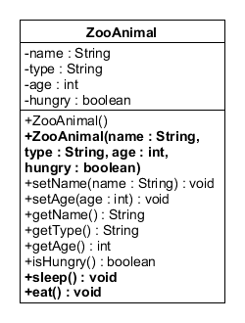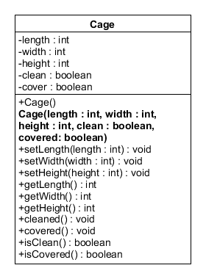

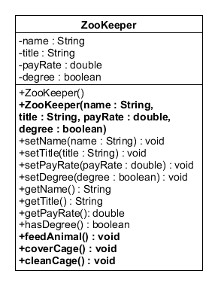

1. Every class has an overloaded constructor that you will use for the creation of objects.

Create a ZooAnimal named Chip. Chip is a brown monkey that is 5 years old and is not hungry.

Create a Cage that has a length of 15, a width of 20, and a height of 15. The cage is not clean and covered.

Create a ZooKeeper named Mr. Jackson Rock. He has no degree and is paid for 15 an hour.

2. There are added new methods for the three classes for better understanding of OOP.

* For ZooAnimal, we have the eat() and sleep() custom methods.

**eat()** method will print out <zooanimal> “is eating…”. After eating, the zooanimal’s hunger will no longer be on the true state.

**sleep()** method will print out <zooanimal> “is sleeping…”. Sleeping will make the animal hungry again.

* For Cage, we have the cleaned() and covered custom methods.

**cleaned()** method will set the clean state to either true or false. It’s a mutator method of the variable clean.

**covered()** method will set the cover state to either true or false. It’s also a mutator method for the variable cover.

* For ZooKeeper, we have the feedanimal(), coverCage(), and cleanCage() methods.

**feedAnimal()** method will print out <zookeeper> “is feeding an animal…”

**coverCage()** method will print out <zookeeper> ”is covering/uncovering the cage…”

**cleanCage()** method will print out <zookeeper> “is cleaning the cage…”

3. On the main method of the JavaZoo class, make a menu type program with four choices: Feed, Put to Sleep, Clean Cage, View all information. Fifth choice is of course an exit.

* Feed - will invoke the eat(), coverCage() and the feedAnimal() methods, making the animal’s hunger to false, cover to false and the cage to be dirty(false). The animal will not eat if the cage is dirty.
* Put to sleep – will invoke the coverCage() and the sleep() methods, making the cover to true and the animal’s hunger to true. The animal will not sleep if he is hungry.
* Clean cage – will invoke the cleanCage() method, making the clean state to true.
* View all Information – like the previous one, will print out all the current details of the ZooAnimal, Cage, and the ZooKeeper.